**Web Technologies**

**Assignment 2 -** Database Driven Website Development Project

**Jordan McElwee**

**Contents**

**Development of Database driven website** 4

**Frameworks** 4

*ASP.NET Framework* 4

*Django (Python)* 4

*Ruby on Rails (Ruby)* 5

*Comparisons between Frameworks and Development Tools* 5

**Development Tools** 6

*Visual Studio 2022* 6

*Sublime Text* 6

*WebStorm* 7

*Comparing Development tools* 7

**Project Proposal** 8

*Initial Project plan* 8

*Revised Plan* 8

**Purpose** 9

*Company Background* 9

*User goals* 9

*Benefits to the Business* 10

**Target Audience** 10

**Client Requirements** 11

*Layout* 11

*Navigation* 11

*Colour scheme* 11

*Interactive features* 12

*Database* 13

*Data Dictionary* 15

**Sitemap** 21

**Storyboards** 22

**Testing** 35

*PAGE NAME: LAYOUT PAGE Responsiveness on Chrome* 35

*PAGE NAME: HOME PAGE* 37

*PAGE NAME: REGISTER PAGE* 41

*PAGE NAME: HOME PAGE* 44

*PAGE NAME: Customer Index PAGE* 48

*PAGE NAME: Customer Create / Edit PAGE* 50

**References** 55

# **Development of Database driven website**

The development of database-driven web solutions requires the utilization of various frameworks and development tools. This project aims to identify and discuss a range of these tools, considering their relative strengths and limitations. Specifically, this project will be using the ASP.NET framework and Visual Studio Code development tool. These respective tools and frameworks will also be compared between alternative frameworks and development tools in terms of their effectiveness and drawbacks in terms of developing a database driven website.

# **Frameworks**

## *ASP.NET Framework*

ASP.NET is a widely used web application framework created by Microsoft that enables developers to build dynamic web applications and services. As Microsoft (2021) states, "ASP.NET Core is a cross-platform, high-performance, open-source framework for building modern, cloud-based, Internet-connected applications." (Roth et al., 2022) It offers numerous features, such as a powerful programming model, support for contemporary web standards, and native support for database integration. The framework is highly scalable and can manage a large volume of users and data. It also provides robust security features, like authentication and authorization, to protect sensitive information.

ASP.NET has an extensive library of pre-built components to accelerate development time. However, it is primarily designed for the Windows platform, which may limit cross-platform compatibility. Additionally, there may be a steeper learning curve for developers who are new to the .NET ecosystem.

## *Django (Python)*

Django is an advanced Python web framework that encourages quick development and clean, pragmatic design. Django's primary goal is to "ease the creation of complex, database-driven websites." (*Django Software Foundation 2021*) It adheres to the Model-View-Template (MVT) architectural pattern and offers built-in support for database integration and web security. The framework is highly modular and reusable, allowing developers to build applications rapidly

Django provides strong support for database migration and schema management, as well as a wide range of third-party libraries and plugins, which can save time and resources during development. The framework also has an active community that contributes to its continuous improvement and offers helpful resources for developers. However, some developers might find the framework somewhat opinionated, meaning that Django has established conventions and default configurations that developers are encouraged to follow. While this can lead to faster development and consistent code, it might limit customization options for developers who want to implement unconventional solutions or require more flexibility in their web application's architecture. Additionally, the learning curve might be steep for developers who are new to Python or web development, as they will need to familiarize themselves with Django's conventions and best practices.

## *Ruby on Rails (Ruby)*

Ruby on Rails, often referred to as Rails, is a server-side web application and full-stack framework based on the Ruby programming language. It follows the Model-View-Controller (MVC) architectural pattern and emphasizes established conventions instead of requiring explicit configurations. Additionally, the DRY (Don't Repeat Yourself) principle lies at the core of its design.

David Heinemeier Hansson, the creator of Ruby on Rails, states that "Rails is an incredible framework that scales both up and down, making it suitable for a wide range of applications" (Hansson, 2022). Rails is well-known for enabling swift development due to its focus on convention over configuration. It also boasts a large and engaged community, contributing to a wealth of resources, libraries, and plugins. Furthermore, Rails includes built-in features for handling database migrations and schema management.

On the downside, Rails may have slower performance compared to alternative frameworks, especially when used for large-scale applications. Moreover, developers who are unfamiliar with Ruby and the Rails ecosystem may face a learning curve when getting started with the platform.

## *Comparisons between Frameworks and Development Tools*

Comparing ASP.NET, Django, and Ruby on Rails requires analysing the unique aspects of each framework in terms of their performance, development speed, flexibility, community support, and learning curve, all within a single context.

ASP.NET is known for its high scalability and performance, making it an ideal choice for larger applications. In contrast, Django is an excellent choice for rapid development and excels in database management, while Ruby on Rails places strong emphasis on convention over configuration, which reduces development time. However, when it comes to performance in large-scale applications, Ruby on Rails is far behind ASP.NET.

In terms of flexibility, ASP.NET may face some limitations in cross-platform compatibility, while Django offers greater adaptability, and Ruby on Rails promotes a streamlined approach to development that follows established conventions. All three frameworks benefit from strong community support, but the availability of resources, libraries, and plugins may vary between them.

ASP.NET's learning curve might be steeper for developers new to the .NET ecosystem, whereas Django could be challenging for those unfamiliar with Python or web development. Ruby on Rails requires an understanding of the Ruby programming language and its ecosystem, which could also present a learning curve for some developers.

Security-wise, ASP.NET has built-in security features and support from Microsoft, Django offers robust security measures and follows the Python community's best practices, and Ruby on Rails has a track record of being a secure framework as well.

When it comes to development tools and ecosystems, ASP.NET developers benefit from Microsoft's Visual Studio and Azure integration, while Django developers can leverage various Python-based tools and libraries, and Ruby on Rails developers can access the wealth of Ruby gems and tools available within the Rails community.

# **Development Tools**

Visual Studio Code, Sublime Text, and Atom are all popular code editors, each offering a unique set of features and catering to different user preferences.

## *Visual Studio 2022*

The development tool of choice for this project is Visual Studio 2022, a powerful integrated development environment (IDE) developed by Microsoft, supporting a wide range of programming languages and frameworks. Visual Studio is designed to "empower developers to create visually stunning, high-performing applications for any platform" (Visual Studio, 2022). It includes advanced features such as IntelliSense code completion, debugging, Git integration, and deep integration with the ASP.NET framework. This IDE offers a comprehensive set of features and tools for efficient software development. It has deep integration with the ASP.NET framework, allowing seamless development of web applications, and supports cross-platform compatibility for developers to use the tool on Windows, macOS, and Linux. However, Visual Studio 2022 can be more resource-intensive compared to lightweight code editors, which may affect performance on lower-end systems. Additionally, it has a steeper learning curve due to the extensive set of features.

It includes advanced features such as IntelliSense code completion, debugging, Git integration, and seamless integration with the ASP.NET framework. This code editor offers a comprehensive set of features and tools for efficient software development and supports cross-platform compatibility, allowing developers to use the tool on Windows, macOS, and Linux. However, Visual Studio Code may require more system resources compared to lightweight code editors, which could affect performance on lower-end systems. Additionally, it may have a steeper learning curve due to the extensive set of features.

## *Sublime Text*

Sublime Text is a fast and lightweight code editor known for its smooth user experience even with large files. It supports macOS, Windows, and Linux platforms and boasts a wide range of plugins for extending functionality, “One of the best things about Sublime Text is its vast ecosystem of plugins and themes” (Sublime Text, 2023) The editor's unique "Goto Anything" feature allows users to quickly navigate to files, symbols, or lines, streamlining the development process. However, Sublime Text is not open-source and requires a paid license for continued use. Additionally, its smaller community compared to Visual Studio Code and Atom might result in fewer available plugins and updates. According to the Sublime Text community-driven documentation project, the editor automates repetitive tasks, enabling developers to focus on crucial aspects of their work (Sublime Text Documentation, n.d.).

## *WebStorm*

WebStorm is a powerful integrated development environment (IDE) which is a specifically “dedicated environment for JavaScript” (JetBrains, 2022) created by JetBrains. It provides smart coding assistance for JavaScript, TypeScript, HTML, and CSS. WebStorm's features include code completion, on-the-fly error detection, powerful navigation and refactoring, and built-in tools for debugging, testing, and version control.

The IDE is known for its excellent performance and seamless integration with various build tools, package managers, and linters. It also offers a wide range of plugins and extensions for further customization. Although WebStorm is a commercial product and requires a paid license, its extensive features and capabilities make it a popular choice for professional web developers.

However, WebStorm can be more resource-intensive compared to lightweight code editors, which may affect performance on lower-end systems. Additionally, it has a steeper learning curve due to the extensive set of features. Despite these factors, its powerful features and strong support from JetBrains make WebStorm a valuable tool for web development.

## *Comparing Development tools*

Visual Studio 2022, Sublime Text, and Atom each have distinct advantages and cater to different user preferences, making the selection of a development tool for web development projects a matter of individual needs and requirements.

Visual Studio 2022 is a powerful IDE with a comprehensive set of features and tools, making it suitable for developers who require advanced functionality. Its deep integration with the ASP.NET framework and support for various programming languages and frameworks give it an edge in versatility. However, the resource-intensive nature of Visual Studio 2022 and its steeper learning curve may be a drawback for some developers, particularly those using lower-end systems or those who are new to programming.

Sublime Text, on the other hand, is known for its fast and lightweight nature, making it ideal for developers who prioritize performance and efficiency. Its "Goto Anything" feature enhances productivity by allowing quick navigation within the code. The downsides of Sublime Text are its non-open-source status, which requires a paid license, and its smaller community, which may result in fewer plugins and updates compared to Visual Studio 2022 and Atom.

Atom offers an open-source and highly customizable alternative, with a wide range of packages available for extending its functionality. Its built-in support for version control and real-time collaboration makes it an attractive choice for developers who value customization and collaborative features. However, Atom's slower performance when handling large files and its relative immaturity compared to Visual Studio 2022 and Sublime Text may lead to stability issues, which could be a concern for some developers.

In conclusion, when choosing a development tool, developers should weigh the specific needs of their projects and their personal preferences. Visual Studio 2022 is best suited for those who require a powerful IDE with advanced features, while Sublime Text is a great choice for developers who prefer a lightweight and efficient tool. Atom, on the other hand, is ideal for those who value an open-source and highly customizable editor with collaborative capabilities.

# **Project Proposal**

## *Initial Project plan*

Initially, my project development had been more generic in terms of approaching how development and implementation would be carried out. Most Tasks were thought to work in conjunction with one another, leaving some time for a break some days.

## *Revised Plan*

Admittedly, as the project progressed, several unexpected challenges arose that led to revisions in the initial plan such as many errors within the code and overall designing process. Tasks had to be broken down much further as some areas required further effort than anticipated. In response to these challenges, I had to revaluate the development plan and prioritize certain features over others. The focus shifted towards ensuring that the core functionalities, such as appointment scheduling, customer management, and staff allocation, were fully functional and stable, while deprioritizing some of the advanced features like product inventory tracking and accessibility features such as a dark mode or text size adjustment.

# **Purpose**

### *Company Background*

Nurture Nook Spa is a high-end, boutique spa that stands as a sanctuary for relaxation and rejuvenation for its clients. Established by a team of dedicated wellness professionals, the spa aims to provide a personalized and memorable experience for each guest. The founders of Nurture Nook Spa have years of experience in the wellness industry and are passionate about offering unique treatments and therapies that cater to the diverse needs of their clientele.

Located in the outskirts of Aghanloo Limavady, Nurture Nook Spa has been thoughtfully designed to promote relaxation, tranquillity, and an escape from the daily stresses of life. The spa offers a comprehensive range of treatments, including massages, facials, body treatments, and holistic therapies. All treatments are provided by highly skilled and experienced therapists who are committed to delivering exceptional service in a warm, inviting environment.

Nurture Nook Spa's success can be attributed to its unwavering dedication to providing top-notch service, attention to detail, and a personalized approach to wellness. The spa's loyal customer base is a testament to the quality and care provided by its expert staff, who consistently go above and beyond to ensure a rejuvenating and transformative experience for each guest.

### *User goals*

Customers of Nurture Nook Spa seek various objectives when interacting with the business. One of the primary goals is to achieve relaxation and rejuvenation through the range of services and treatments offered. They desire a tranquil environment where they can unwind and escape from the daily stresses of life.

Another goal of the customers is to receive personalized and attentive service. They appreciate the individualized approach to wellness and expect treatments tailored to their specific needs and preferences. This includes addressing any concerns they may have and offering professional advice on the most suitable treatments. Customers want access to a comprehensive selection of high-quality treatments and therapies. They are interested in exploring various options, such as massages, facials, body treatments, and holistic therapies, all provided by skilled and experienced therapists.

Convenience and flexibility are also essential goals for customers. They expect a seamless process when it comes to booking appointments, managing their schedules, and communicating with the spa. This includes the ability to quickly find available time slots, reschedule appointments when necessary, and receive prompt assistance from the staff.

Lastly, customers value a clean, hygienic, and well-maintained spa environment. They expect the facilities and treatment rooms to be immaculate, ensuring a comfortable and safe experience during their visit. They also appreciate an aesthetically pleasing atmosphere that promotes relaxation and enhances their overall spa experience.

### *Benefits to the Business*

Creating a website for Nurture Nook Spa will provide numerous benefits to the business. An online presence will help the spa reach a wider audience and increase its visibility, making it easier for potential customers to discover its services and offerings. A professional and user-friendly website will also enhance the spa's credibility and reputation, showcasing its commitment to high-quality services and customer satisfaction.

A well-designed website will improve the customer experience by providing easy access to essential information about the spa's services, staff, and location. It will allow customers to book appointments with ease, manage their schedules, and communicate with the spa staff when necessary. This convenience will contribute to customer satisfaction and encourage repeat visits.

The website can also serve as a platform for Nurture Nook Spa to share valuable content, such as wellness tips, promotional offers, and news about upcoming events. By providing engaging and relevant content, the spa can establish itself as an authority in the wellness industry and attract potential customers.

In addition, the website can help streamline the spa's operations by integrating online booking and appointment management systems. This will reduce administrative workload, optimize staff schedules, and enhance overall operational efficiency. Utilizing the MVC (Model-View-Controller) architecture, the website can efficiently separate the concerns of data management, user interface, and control flow. This separation ensures easier maintainability, scalability, and adaptability as the spa's needs evolve over time.

The integration of a database within the MVC architecture can further improve the customer experience by offering personalized services based on customer preferences and booking history. This approach allows for seamless data retrieval and manipulation, enabling Nurture Nook Spa to deliver targeted promotions, tailored treatment suggestions, and improved communication with customers. The use of a database within the MVC framework will not only enhance the user experience but also contribute to more efficient and organized management of the spa's operations.

Ultimately, a well-designed website can significantly benefit Nurture Nook Spa by increasing its visibility, enhancing its reputation, improving customer experience, and streamlining its operations. This, in turn, can lead to increased bookings, customer loyalty, and business growth.

# **Target Audience**

The target audience for Nurture Nook Spa includes individuals seeking various spa treatments and services to enhance their well-being. To better understand the characteristics of the target audience, we can examine aspects such as gender, age, and needs.

Nurture Nook Spa welcomes both men and women, offering a diverse range of services and treatments tailored to the unique preferences and requirements of each gender. This inclusive approach ensures that every customer feels valued and comfortable during their visit.

The primary age group targeted by the spa includes adults between 21 and 60 years old. This demographic often experiences the pressures of work, family, and social life, making them more inclined to seek respite and rejuvenation through spa services due to the hectic nature of life. However, the spa's offerings aren’t limited to this age range, and can certainly accommodate other age groups as well, resulting in a versatile target audience.

In terms of needs, the target audience is primarily looking for a tranquil environment where they can focus on self-care and personal well-being within the local Limavady area. They desire high-quality treatments and therapies that address stress relief, relaxation, and overall wellness. Additionally, they appreciate attentive service tailored to their specific preferences, as well as convenient and flexible booking options. A clean, hygienic, and inviting atmosphere is also important to the target audience.

# **Client Requirements**

The client requirements for the Nurture Nook Spa website focus on delivering a professional and user-friendly design that meets the needs of both the spa's owners and its target audience. The owner of the site would typically expect the design to have a professional layout and be easy to navigate.

## *Layout*

A professional layout encompasses a clean and modern design, reflecting the brand identity and the quality of services offered by the spa. A visually appealing website with an organized structure will create a positive first impression and encourage users to explore the site further.

## *Navigation*

The website should also prioritize ease of navigation, ensuring that users can quickly find the information they need. A clear and consistent navigation menu should be present, guiding visitors through the site's various sections, including services, pricing, and booking options.

When outlining the structure of the website, attention should be given to the colour scheme, graphical elements, and interactive content. Graphical elements, such as images and icons, should be high-quality and relevant to the content, enhancing the overall aesthetic and user experience.

## *Colour scheme*

A soothing and elegant colour scheme for the Nurture Nook Spa website should evoke a sense of tranquillity and relaxation in line with the nature of spa services. A combination of earthy tones, paired with neutral shades, can create a harmonious and visually appealing aesthetic.

For the main colour, consider using a warm beige or sand tone, which represents calmness and serenity. This colour can be applied to headings, buttons, and other primary design elements. An accent colour, such as a soft terracotta or muted coral, can be used sparingly to highlight important information or create visual interest, adding a touch of warmth and sophistication to the design.

A neutral base colour, like a light grey or off-white, can serve as the background for the website, providing a clean and uncluttered canvas that allows the main and accent colours to stand out. Using these colours strategically throughout the website will create a cohesive and inviting visual identity that aligns with the spa's atmosphere and branding.

## *Interactive features*

In order to enhance the user experience and make the Nurture Nook Spa website more engaging, incorporating various interactive features is essential. One of the interactive elements to include is popup dialog boxes for team members. To showcase the therapists, a carousel can be used that contains three images per page. When users click on an image, a popup dialog box will appear, providing more information about the therapist, their expertise, and qualifications. This approach allows visitors to learn more about the team members and their areas of specialization.

Another interactive feature to incorporate is hover effects that highlight or zoom in on images. When a user hovers over an image, it can either become brighter, display additional information, or zoom in slightly. This effect creates a more dynamic browsing experience and encourages users to explore the website further.

Interactive forms can be integrated into the website to streamline various processes, such as booking appointments, requesting more information, or registering an account. These forms should be designed to be intuitive and user-friendly, ensuring that visitors can easily complete the required actions.

Accordions can be implemented to present information about the spa's treatments and services in an organized and concise manner. For example, the spa may offer various types of massages, facials, and body treatments. Using accordions, the website can neatly display each category of treatments, with users being able to expand the relevant sections to view more information about the specific services offered. This approach ensures that visitors can easily find the information they are looking for without being overwhelmed by a large amount of text.

Cards can be used on the website to showcase individual services, treatments, or special offers in a visually appealing way. Each card can contain an image of the treatment or the treatment room, a brief description of the service, and pricing information. By using cards, the website can visually guide users through the various options available at the spa, making it easier for them to find and choose the treatments that best suit their needs and preferences. The cards can also be designed to incorporate the hover effects mentioned earlier, further enhancing the user experience.

## *Database*

To develop a comprehensive database for Nurture Nook, a spa management system, the following requirements need to be addressed. This system will incorporate elements such as CRUD (Create, Read, Update, and Delete) operations, search facilities, and partial views to streamline the website's functionality and enhance user experience.

User management will be implemented to store and manage user information, including registration, authentication, and authorization. This will involve creating different user roles such as admin, manager, and customer to ensure appropriate access control.

A system to maintain a record of all therapists, along with their specializations and contact information, will be created. Admin users will have the ability to add, update, or delete therapist information as needed.

The management of various services and treatments provided at Nurture Nook is essential. The database will store descriptions, durations, and prices of these services, allowing admin users to add, update, or delete services as required.

Customer information, including name, email, phone number, and registration date, will be stored in the database. Customers will have the ability to update their information and manage their preferences and history.

The appointment booking process will enable customers to search for available services and therapists, book appointments, and view or modify their bookings. The system will ensure appropriate time slots are allocated based on service duration and therapist availability and will include functionality for therapists and admin users to manage appointments.

Search facilities will be incorporated to help customers find relevant services, therapists, and appointment slots easily. Filters for search results based on user preferences or booking history will be implemented to refine the search experience.

Partial views will be utilized to display personalized content such as recommendations, promotions, and booking history. This feature will be based on user preferences or browsing history, enhancing the personalization of the Nurture Nook experience.

By integrating these features and requirements, Nurture Nook can provide a user-friendly platform for customers and employees to manage their spa experiences while optimizing the spa's internal processes and business performance.

**Test cases**

**Check website and Database work on another laptop.**

### *Data Dictionary*

#### Table: Therapists

|  |  |  |  |  |
| --- | --- | --- | --- | --- |
| **Field** | **Data Type** | **Key** | **Description** | **Data Annotations** |
| TherapistID | INT IDENTITY(1,1) | Primary Key, Auto Increment | Unique identifier for each therapist |  |
| FirstName | NVARCHAR(50) NOT NULL | - | First name of the therapist | [StringLength(50, ErrorMessage = "First name cannot be longer than 50 characters.")]  [Required(ErrorMessage = "First name is required.")]  [Display(Name = "First Name")] |
| LastName | NVARCHAR(50) NOT NULL | - | Last name of the therapist | [StringLength(50, ErrorMessage = "Last name cannot be longer than 50 characters.")]  [Required(ErrorMessage = "Last name is required.")]  [Display(Name = "Last Name")] |
| Specialization | NVARCHAR(100) | - | Specialization or expertise of the therapist | [StringLength(100, ErrorMessage = "Specialization cannot be longer than 100 characters.")]  [Display(Name = "Specialization")] |

#### Table: Services

|  |  |  |  |  |
| --- | --- | --- | --- | --- |
| **Field** | **Data Type** | **Key** | **Description** | **Data Annotations** |
| ServiceID | INT IDENTITY(1,1) | Primary Key, Auto Increment | Unique identifier for each service |  |
| ServiceName | NVARCHAR(50) NOT NULL | - | Name of the service provided | [StringLength(50, ErrorMessage = "Service name cannot be longer than 50 characters.")]  [Required(ErrorMessage = "Service name is required.")]  [Display(Name = "Service")] |
| Description | NVARCHAR(50) | - | Brief description of the service | [StringLength(50, ErrorMessage = "Description cannot be longer than 50 characters.")]  [Display(Name = "Description")] |
| Duration | INT NOT NULL | - | Duration of the service in minutes | [Required(ErrorMessage = "Duration is required.")]  [Display(Name = "Duration (minutes)")] |
| Price | money | - | Price of the service (nullable if not available) | [Display(Name = "Price")]  [DataType(DataType.Currency)] |

#### Table: Customers

|  |  |  |  |  |
| --- | --- | --- | --- | --- |
| **Field** | **Data Type** | **Key** | **Description** | **Data Annotations** |
| CustomerID | INT IDENTITY(1,1) | Primary Key, Auto Increment | Unique identifier for each customer |  |
| FirstName | NVARCHAR(50) NOT NULL | - | First name of the customer | [StringLength(30, ErrorMessage = "First name cannot be longer than 30 characters.")]  [Required(ErrorMessage = "First name is required.")]  [Display(Name = "First Name")] |
| LastName | NVARCHAR(50) NOT NULL | - | Last name of the customer | [StringLength(30, ErrorMessage = "Last name cannot be longer than 30 characters.")]  [Required(ErrorMessage = "Last name is required.")]  [Display(Name = "Last Name")] |
| Email | NVARCHAR(100) NOT NULL | - | Email address of the customer | [StringLength(50, ErrorMessage = "Email cannot be longer than 50 characters.")]  [Required(ErrorMessage = "Email is required.")]  [EmailAddress(ErrorMessage = "Invalid email address.")]  [Display(Name = "Email")] |
| PhoneNumber | NVARCHAR(20) NOT NULL | - | Phone number of the customer | [StringLength(13, ErrorMessage = "Phone number cannot be longer than 13 characters.")]  [Required(ErrorMessage = "Phone number is required.")]  [Display(Name = "Phone Number")] |
| RegistrationDate | DATETIME NOT NULL | - | Date when the customer registered | [Required(ErrorMessage = "Registration date is required.")]  [Display(Name = "Registration Date")]  [DataType(DataType.Date)]  [DisplayFormat(DataFormatString = "{0:dd/MM/yyyy}", ApplyFormatInEditMode = true)] |

#### Table: Appointments

|  |  |  |  |  |
| --- | --- | --- | --- | --- |
| **Field** | **Data Type** | **Key** | **Description** | **Data Annotations** |
| AppointmentID | INT IDENTITY(1,1) | Primary Key, Auto Increment | Unique identifier for each appointment |  |
| DateBooked | DATETIME NOT NULL | - | Date when the appointment was booked | [Required(ErrorMessage = "Date booked is required.")]  [Display(Name = "Date Booked")]  [DataType(DataType.DateTime)]  [DisplayFormat(DataFormatString = "{0:dd/MM/yyyy}", ApplyFormatInEditMode = true)] |
| StartTime | DATETIME NOT NULL | - | Scheduled start time of the appointment | [Required(ErrorMessage = "Start time is required.")]  [Display(Name = "Start Time")]  [DataType(DataType.Time, ErrorMessage = "Please enter a valid time")]  [StartTimeValidation] |
| EndTime | DATETIME NOT NULL | - | Scheduled end time of the appointment | [Required(ErrorMessage = "End time is required.")]  [Display(Name = "End Time")]  [DataType(DataType.Time, ErrorMessage = "Please enter a valid time")]  [EndTimeValidation] |
| CustomerID | INT NOT NULL | Foreign Key | ID of the customer who booked the appointment | [Display(Name = "Customer Name")] |
| TherapistID | INT NOT NULL | Foreign Key | ID of the therapist assigned to the appointment | [Display(Name = "Therapist")] |
| ServiceID | INT NOT NULL | Foreign Key | ID of the service to be provided during the appointment | [Display(Name = "Service")] |
| Notes | NVARCHAR(100) | - | Optional notes about the appointment | [StringLength(100, ErrorMessage = "Notes cannot be longer than 100 characters.")]  [Display(Name = "Notes")] |

# **Sitemap**

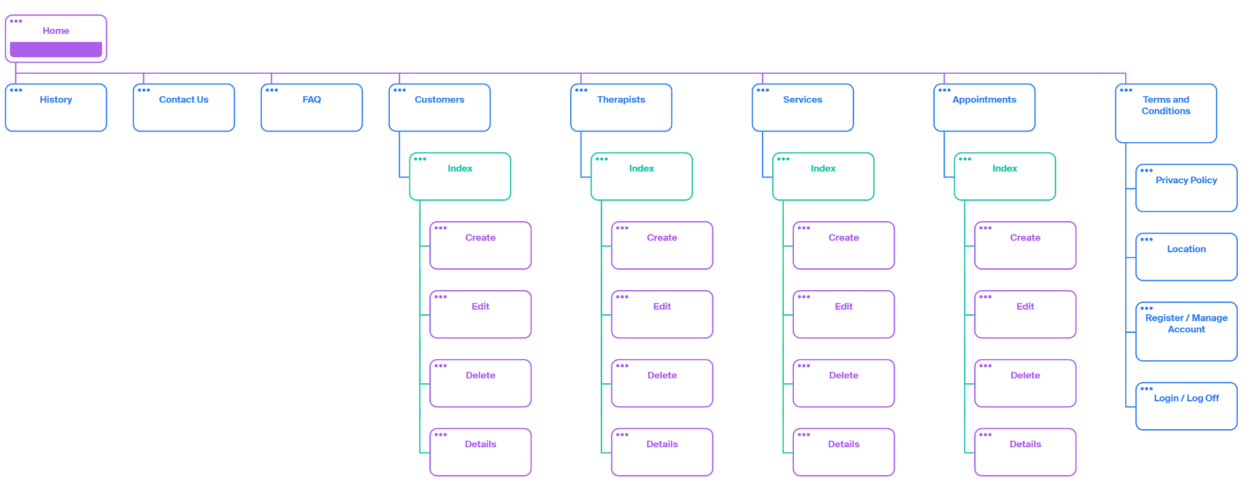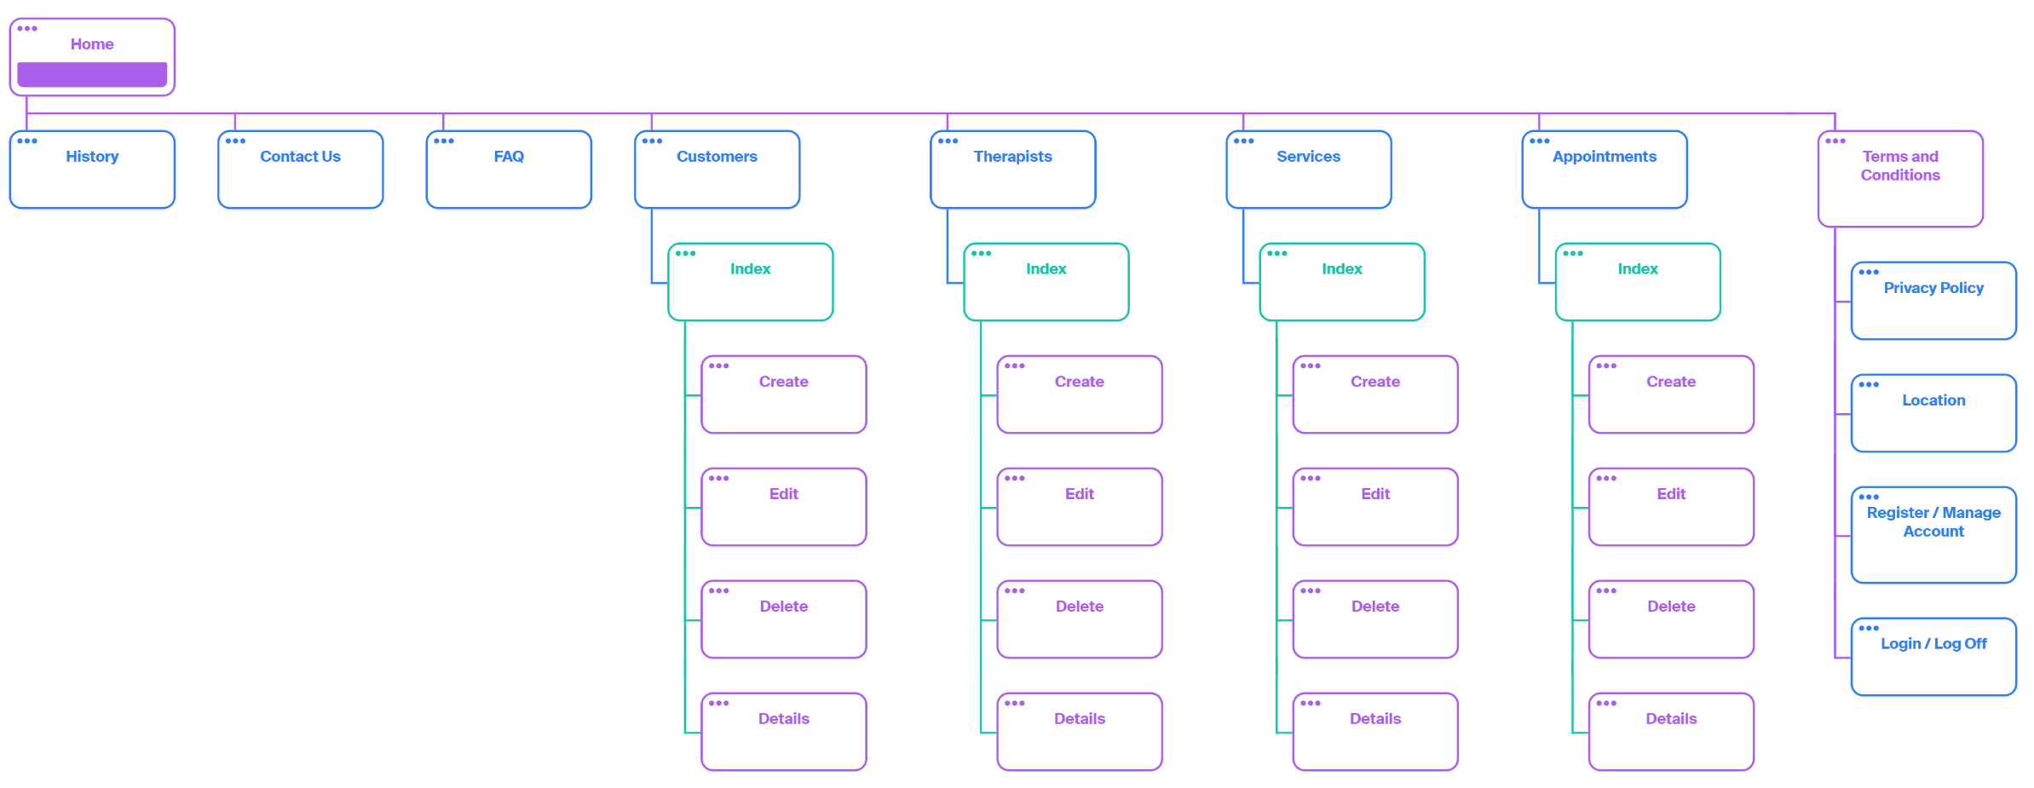

# **Storyboards**

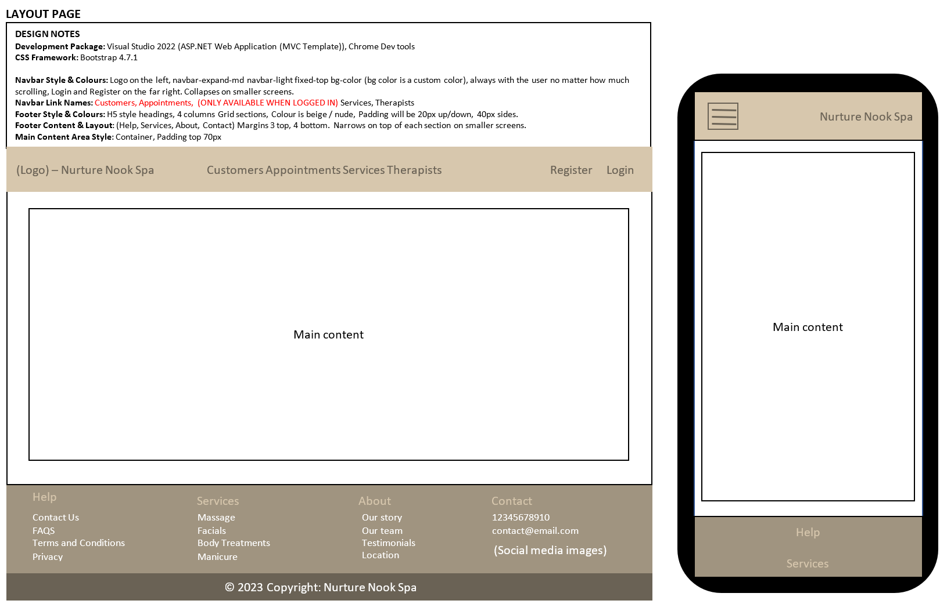

**Database Type:** SQL Server

(py-3)

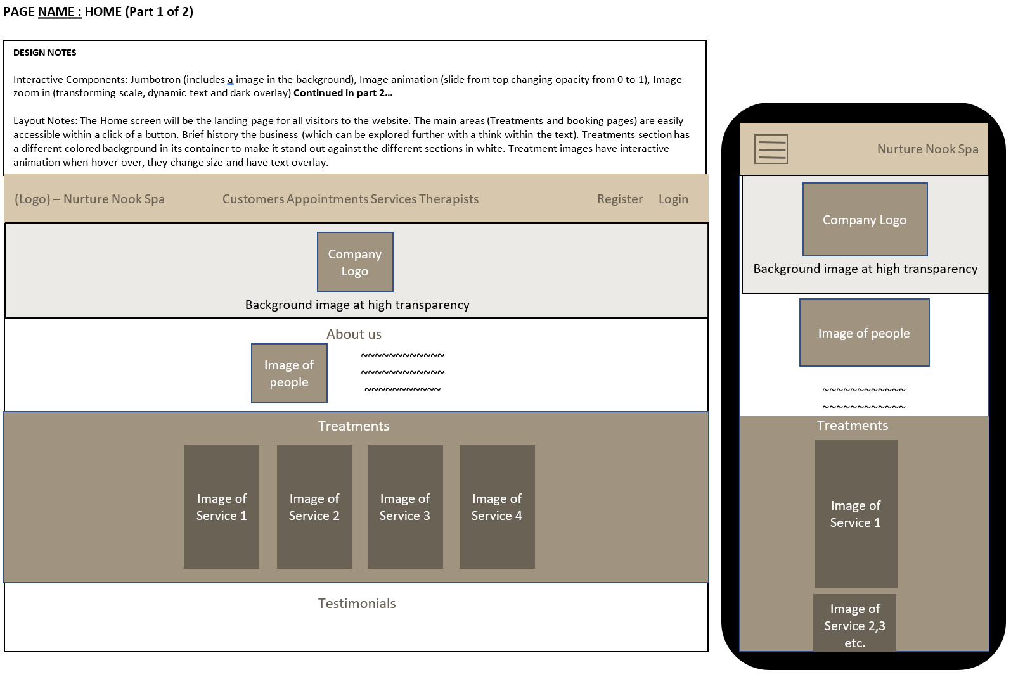

*Modal cut from production*

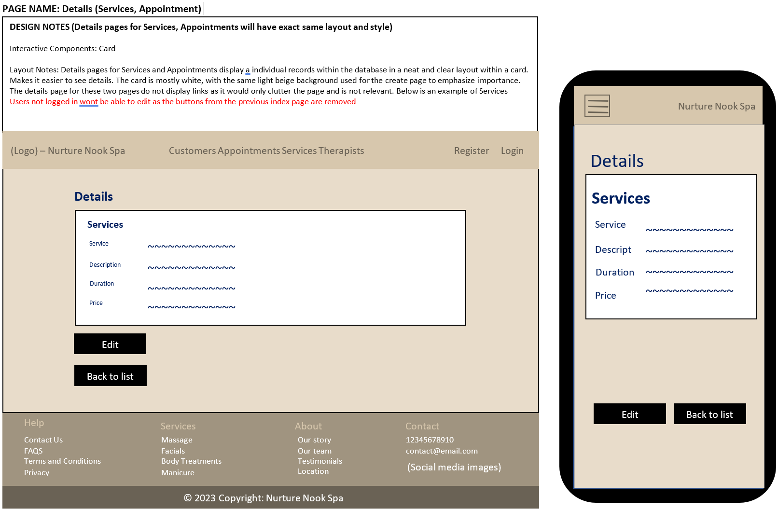

# **Testing**

### *PAGE NAME: LAYOUT PAGE Responsiveness on Chrome*

|  |  |  |  |  |
| --- | --- | --- | --- | --- |
| **Test No** | **Test** | **Expected Outcome** | **Actual Outcome** | **Action Taken** |
| 1 | Page loads | Nav bar at top, menu options visible  Not logged in from initial load  Website header stretches the full width of the page. Text is dark brown, main background is white  Footer stretches across the bottom of the page four headings for help services about and contact with social media icons side by side under Contact. Colour is a dark beige. | Somewhat as expected  *Social media icons don’t load on some pages, however alt text is displayed and links still work  * | On the backlog for now as functionality is still present. |

**Responsiveness on Mobile Device**

|  |  |  |  |  |
| --- | --- | --- | --- | --- |
| **Test No** | **Test** | **Expected Outcome** | **Actual Outcome** | **Action Taken** |
| 1 | Page loads | Collapsed menu at top,  Logo still displayed  Not logged in from initial load  Website header stretches the full width of the page. Text is dark brown, main background is white  Footer stretches below main content, stacking the sections of the four headings for help services about and contact with social media icons side by side under Contact. Colour is a dark beige. | Somewhat as expected  *See previous test case for chrome* | On the backlog for now as functionality is still present |

**Functionality Testing**

|  |  |  |  |  |  |
| --- | --- | --- | --- | --- | --- |
| **Test No** | **Test** | **Expected Outcome** | **Actual Outcome on Chrome** | **Actual Outcome on Mobile Device** | **Action Taken** |
| 1 | Click on Logo link | Home page displayed | As expected | As expected |  |
| 2 | Navlinks for Customer and Appointments hidden | Hidden if user is not logged in | As expected | As expected |  |
| 3 | Navlinks for Customer and Appointments appear | Hidden if user is logged in | As expected | As expected |  |
| 4 | Click on customers | Directed to Customer Index page | As expected | As expected |  |
| 5 | Click on appointments | Directed to appointments Index page | As expected | As expected |  |
| 6 | Click on services | Directed to services Index page | As expected | As expected |  |
| 7 | Click on therapists | Directed to therapists Index page | As expected | As expected |  |
| 8 | Click on register | Directed to register page | As expected | As expected |  |
| 9 | Click on log in | Directed to log in page | As expected | As expected |  |
| 10 | Click on Log off | User is redirected back to home page | As expected | As expected |  |
| 11 | Click on collapsed menu | Opens the list of Nav links | As expected | As expected |  |
| 12 | Hover over footer links | Change colour to orange and underline | As expected | As expected |  |
| 13 | Click on Facebook icon | Redirects to Facebook | As expected | As expected |  |
| 14 | Click on Twitter icon | Redirects to Twitter | As expected | As expected |  |
| 15 | Click on YouTube icon | Redirects to YouTube | As expected | As expected |  |
| 16 | Click on LinkedIn icon | Redirects to LinkedIn | As expected | As expected |  |

### *PAGE NAME: HOME PAGE*

**Responsiveness on Chrome**

|  |  |  |  |  |
| --- | --- | --- | --- | --- |
| **Test No** | **Test** | **Expected Outcome** | **Actual Outcome** | **Action Taken** |
| 1 | Main content loads | Jumbotron loads with background image, logo fading in from top.  About us image loads  Treatment Images load, with container behind coloured beige  Cards for customer reviews should load  Embedded Google map should load, filling the width of the page  Book Now button should be disabled if user is not logged in | Not as expected  Book now button loads which allows a user to break security, and can create bookings for any customer.   | Fixed, users who aren’t registered / logged in cannot access the page   |

**Responsiveness on Mobile Device**

|  |  |  |  |  |
| --- | --- | --- | --- | --- |
| **Test No** | **Test** | **Expected Outcome** | **Actual Outcome** | **Action Taken** |
| 1 | Main content loads | Jumbotron loads with background image, logo fading in from top.  About us image loads  Treatment Images load, with container behind coloured beige  Cards for customer reviews should load  Embedded Google map should load, filling the width of the page  Book Now button should be disabled if user is not logged in | As Expected, fixed previously |  |

**Functionality Testing**

|  |  |  |  |  |  |
| --- | --- | --- | --- | --- | --- |
| **Test No** | **Test** | **Expected Outcome** | **Actual Outcome on Chrome** | **Actual Outcome on Mobile Device** | **Action Taken** |
| 1 | Click on History card link | Directed to Our Story page | As expected | As expected |  |
| 2 | Click on Team card link | Directed to Therapists index page | As expected | As expected |  |
| 3 | Hover on Treatment image Hot Stone | Image should darken and enlarge, with text overlay | As expected | As expected |  |
| 4 | Hover on Treatment image Facial | Image should darken and enlarge, with text overlay | As expected | As expected |  |
| 5 | Hover on Treatment image Pedicure | Image should darken and enlarge, with text overlay | As expected | As expected |  |
| 6 | Hover on Treatment image Massage | Image should darken and enlarge, with text overlay | As expected | As expected |  |
| 7 | Click on Treatment image Hot Stone | Redirected to Details page for database item “Hot Stone” | As expected | As expected |  |
| 8 | Click on Treatment image Facial | Redirected to Details page for database item Facial | As expected | As expected |  |
| 9 | Click on Treatment image Pedicure | Redirected to Details page for database item Pedicure | A screenshot of a computer  Description automatically generated with low confidence  Not as expected, Service doesn’t exist to redirect to | Not as expected | Backlogged due to time constraints, services automatically created need to be automatically added to the Treatment cards in the home page for proper redirect |
| 10 | Click on Treatment image Massage | Redirected to Details page for database item Massage | As expected | As expected |  |
| 11 | Hover over customer review 1 | Enlarges the card | As expected | As expected |  |
| 12 | Hover over customer review 2 | Enlarges the card | As expected | As expected |  |
| 13 | Hover over customer review 3 | Enlarges the card | As expected | As expected |  |
| 14 | Google Map is interactable | Google map controls work as intended, and displays correct directions | As expected | As expected |  |
| 15 | Book now button clicked | Book now click redirects to Appointments create page | As expected | As expected |  |

### *PAGE NAME: REGISTER PAGE*

**Responsiveness on Chrome**

|  |  |  |  |  |
| --- | --- | --- | --- | --- |
| **Test No** | **Test** | **Expected Outcome** | **Actual Outcome** | **Action Taken** |
| 1 | Main content loads | Register page loads with no information already entered  Background image loads with 50% opacity | As expected | As expected |

**Responsiveness on Mobile Device**

|  |  |  |  |  |
| --- | --- | --- | --- | --- |
| **Test No** | **Test** | **Expected Outcome** | **Actual Outcome** | **Action Taken** |
| 1 | Main content loads | Register page loads with no information already entered  Background image loads with 50% opacity | As expected | As expected |

**Functionality Testing**

|  |  |  |  |  |  |
| --- | --- | --- | --- | --- | --- |
| **Test No** | **Test** | **Expected Outcome** | **Actual Outcome on Chrome** | **Actual Outcome on Mobile Device** | **Action Taken** |
| 1 | Clicking on text boxes | Allows input to be entered | As expected | As expected |  |
| 2 | First and Last names left blank | Error message should appear advising user to enter names, account cannot be created | Not a expected, user created without names   | Same outcome | A screenshot of a phone  Description automatically generated with low confidence Annotations added to RegisterViewModel, working as expected  [Required(ErrorMessage = "First Name is required.")]  [Required(ErrorMessage = "Last Name is required.")] |
| 3 | Entering  *john@hotmail* | Email field will not accept emails in the incorrect format | Not as expected, emails without a domain such as .com, .co.uk, .gov etc are still processed   | Same outcome | A picture containing text, screenshot, font, line  Description automatically generated  Annotations added to invalidate blank domains [Required(ErrorMessage = "Email is required.")]  [RegularExpression(@"^[\w-\.]+@([\w-]+\.)+[\w-]{2,4}$", ErrorMessage = "Invalid email address format.")] |
| 4 | Passwords not matching | Passwords not matching are flagged to the user, cannot proceed to register | As expected | As expected |  |
| 5 | Email field left blanks | Flagged as an invalid format | As expected | As expected |  |
| 6 | Entering *Johnhotmail* in email | Flagged as an invalid format | As expected | As expected |  |
| 7 | Entering @.com in email | Flagged as an invalid format | As expected | As expected |  |
| 8 | Leaving password blank | Flags to user password needs to be longer than 6 characters | As expected | As expected |  |
| 9 | Leaving confirm password blank | Flags to user password needs to match | As expected | As expected |  |
| 10 | Entering non matching password in confirm password | Flags to user password needs to match | As expected | As expected |  |
| 11 | Clicking register with an incomplete field | Will not proceed with registration | As expected | As expected |  |

### *PAGE NAME: HOME PAGE*

**Responsiveness on Chrome**

|  |  |  |  |  |
| --- | --- | --- | --- | --- |
| **Test No** | **Test** | **Expected Outcome** | **Actual Outcome** | **Action Taken** |
| 1 | Main content loads | Jumbotron loads with background image, logo fading in from top.  About us image loads  Treatment Images load, with container behind coloured beige  Cards for customer reviews should load  Embedded Google map should load, filling the width of the page  Book Now button should be disabled if user is not logged in | Not as expected  Book now button loads which allows a user to break security, and can create bookings for any customer.   | Fixed, users who aren’t registered / logged in cannot access the page   |

**Responsiveness on Mobile Device**

|  |  |  |  |  |
| --- | --- | --- | --- | --- |
| **Test No** | **Test** | **Expected Outcome** | **Actual Outcome** | **Action Taken** |
| 1 | Main content loads | Jumbotron loads with background image, logo fading in from top.  About us image loads  Treatment Images load, with container behind coloured beige  Cards for customer reviews should load  Embedded Google map should load, filling the width of the page  Book Now button should be disabled if user is not logged in | As Expected, fixed previously |  |

**Functionality Testing**

|  |  |  |  |  |  |
| --- | --- | --- | --- | --- | --- |
| **Test No** | **Test** | **Expected Outcome** | **Actual Outcome on Chrome** | **Actual Outcome on Mobile Device** | **Action Taken** |
| 1 | Click on History card link | Directed to Our Story page | As expected | As expected |  |
| 2 | Click on Team card link | Directed to Therapists index page | As expected | As expected |  |
| 3 | Hover on Treatment image Hot Stone | Image should darken and enlarge, with text overlay | As expected | As expected |  |
| 4 | Hover on Treatment image Facial | Image should darken and enlarge, with text overlay | As expected | As expected |  |
| 5 | Hover on Treatment image Pedicure | Image should darken and enlarge, with text overlay | As expected | As expected |  |
| 6 | Hover on Treatment image Massage | Image should darken and enlarge, with text overlay | As expected | As expected |  |
| 7 | Click on Treatment image Hot Stone | Redirected to Details page for database item “Hot Stone” | As expected | As expected |  |
| 8 | Click on Treatment image Facial | Redirected to Details page for database item Facial | As expected | As expected |  |
| 9 | Click on Treatment image Pedicure | Redirected to Details page for database item Pedicure | A screenshot of a computer  Description automatically generated with low confidence  Not as expected, Service doesn’t exist to redirect to | Not as expected | Backlogged due to time constraints, services automatically created need to be automatically added to the Treatment cards in the home page for proper redirect |
| 10 | Click on Treatment image Massage | Redirected to Details page for database item Massage | As expected | As expected |  |
| 11 | Hover over customer review 1 | Enlarges the card | As expected | As expected |  |
| 12 | Hover over customer review 2 | Enlarges the card | As expected | As expected |  |
| 13 | Hover over customer review 3 | Enlarges the card | As expected | As expected |  |
| 14 | Google Map is interactable | Google map controls work as intended, and displays correct directions | As expected | As expected |  |
| 15 | Book now button clicked | Book now click redirects to Appointments create page | As expected | As expected |  |

### *PAGE NAME: Customer Index PAGE*

**Responsiveness on Chrome**

|  |  |  |  |  |
| --- | --- | --- | --- | --- |
| **Test No** | **Test** | **Expected Outcome** | **Actual Outcome** | **Action Taken** |
| 1 | Main content loads | Database of customer loads  Create new button loads  Date search function loads   Buttons for Edit, Details and Delete load | As expected | As expected |

**Responsiveness on Mobile Device**

|  |  |  |  |  |
| --- | --- | --- | --- | --- |
| **Test No** | **Test** | **Expected Outcome** | **Actual Outcome** | **Action Taken** |
| 1 | Main content loads | Database of customer loads  Create new button loads  Date search function loads   Buttons for Edit, Details and Delete load | As expected | As expected |

**Functionality Testing**

|  |  |  |  |  |  |
| --- | --- | --- | --- | --- | --- |
| **Test No** | **Test** | **Expected Outcome** | **Actual Outcome on Chrome** | **Actual Outcome on Mobile Device** | **Action Taken** |
| 1 | Clicking create new | Directs to Create customer | As expected | As expected |  |
| 2 | Searching for “01/01/2023” | Returns Customer “Jordan” | As expected | As expected |  |
| 3 | Searching for blank date | Returns all customers | As expected | As expected |  |
| 4 | Clicking Edit button for “Jordan” | Taken to Edit customer page for customer “Jordan” | As expected | As expected |  |
| 5 | Clicking Details button for “Jordan” | Displays Details page for Customer “Jordan” | As expected | As expected |  |
| 6 | Clicking Delete button for “Jordan” | Displays Delete page for Customer “Jordan” | As expected | As expected |  |
| 7 | Hover over edit | Button fills in with colour beige, text turns to white | As expected | As expected |  |
| 8 | Hover over Details | Button fills in with colour beige, text turns to white | As expected | As expected |  |

### *PAGE NAME: Customer Create / Edit PAGE*

**Responsiveness on Chrome**

|  |  |  |  |  |
| --- | --- | --- | --- | --- |
| **Test No** | **Test** | **Expected Outcome** | **Actual Outcome** | **Action Taken** |
| 1 | Main content loads | Form loads with text boxes  Background colour changes to light beige  **Edit form – Customer details load and can be updated** | As expected | As expected |

**Responsiveness on Mobile Device**

|  |  |  |  |  |
| --- | --- | --- | --- | --- |
| **Test No** | **Test** | **Expected Outcome** | **Actual Outcome** | **Action Taken** |
| 1 | Main content loads | Form loads with text boxes  Background colour changes to light beige  **Edit form – Customer details load and can be updated** | As expected | As expected |

**Functionality Testing**

|  |  |  |  |  |  |
| --- | --- | --- | --- | --- | --- |
| **Test No** | **Test** | **Expected Outcome** | **Actual Outcome on Chrome** | **Actual Outcome on Mobile Device** | **Action Taken** |
| 1 | Text boxes on click | Allows inputs to be registered | As expected | As expected |  |
| 2 | First name left blank | Error message appears asking for an input | As expected | As expected |  |
| 3 | Last name left blank | Error message appears asking for an input | As expected | As expected |  |
| 4 | Email left blank | Error message appears asking for an input | As expected | As expected |  |
| 5 | Phone no left blank | Error message appears asking for an input | As expected | As expected |  |
| 6 | Date left blank | Error message appears asking for an input | As expected | As expected |  |
| 7 | Entering  *john@hotmail* | Email field will not accept emails in the incorrect format | As expected | As expected |  |
| 8 | Email field left blanks | Flagged as an invalid format | As expected | As expected |  |
| 9 | Entering *Johnhotmail* in email | Flagged as an invalid format | As expected | As expected |  |
| 10 | Entering @.com in email | Flagged as an invalid format | As expected | As expected |  |

|  |  |  |  |  |
| --- | --- | --- | --- | --- |
| **Test No** | **Test** | **Expected Outcome** | **Actual Outcome** | **Action Taken** |
| 1 | Main content loads | Form loads with text boxes  Background colour changes to light beige  **Edit form – Customer details load and can be updated** | As expected | As expected |

**Other Tests**

|  |  |  |  |  |
| --- | --- | --- | --- | --- |
| **Test** | **Expected Outcome** | **Actual Outcome on Chrome** | **Actual Outcome on Mobile Device** | **Action Taken** |
| Test carousel images | All images load same height and width | As expected | As expected |  |
| Test carousel arrows | Carousel moves to next/previous images | As expected | As expected |  |
| Test the list of services | All services displayed correctly | As expected | As expected |  |
| Test Add Service functionality | New service added to list | As expected | As expected |  |
| Test Edit Service functionality | Existing service can be edited | As expected | As expected |  |
| Test Delete Service functionality | Existing service can be deleted | As expected | As expected |  |
| Test the list of therapists | All therapists displayed correctly | As expected | As expected |  |
| Test Add Therapist functionality | New therapist added to list | As expected | As expected |  |
| Test Edit Therapist functionality | Existing therapist can be edited | As expected | As expected |  |
| Test Delete Therapist functionality | Existing therapist can be deleted | As expected | As expected |  |
| Test the list of customers | All customers displayed correctly | As expected | As expected |  |
| Test Add Customer functionality | New customer added to list | As expected | As expected |  |
| Test Edit Customer functionality | Existing customer can be edited | As expected | As expected |  |
| Test Delete Customer functionality | Existing customer can be deleted | As expected | As expected |  |
| Test the list of appointments | All appointments displayed correctly | As expected | As expected |  |
| Test Add Appointment functionality | New appointment added to list | As expected | As expected |  |
| Test Edit Appointment functionality | Existing appointment can be edited | As expected | As expected |  |
| Test Delete Appointment functionality | Existing appointment can be deleted | As expected | As expected |  |

**\*\*Other tests were documented in the videos\*\***

# **References**

*Django* (2023) *Django Project*. Available at: https://www.djangoproject.com/ (Accessed: May 1, 2023).

Hansson, D. (2022) *Ruby on rails*, *Ruby on Rails*. Available at: https://rubyonrails.org/ (Accessed: May 1, 2023).

Roth, D., Anderson, R. and Luttin, S. (2022) *Overview of ASP.NET core*, *Microsoft Learn*. Available at: https://docs.microsoft.com/en-us/aspnet/core/introduction-to-aspnet-core?view=aspnetcore-5.0 (Accessed: May 1, 2023).

*The sophisticated text editor for Code, markup and prose* (2023) *Sublime Text*. Available at: https://www.sublimetext.com/ (Accessed: May 7, 2023).

*Visual studio 2022: Download for free* (2023) *Visual Studio*. Microsoft. Available at: https://visualstudio.microsoft.com/vs/ (Accessed: May 2, 2023).

*Webstorm: Features* (2022) *JetBrains*. Available at: https://www.jetbrains.com/webstorm/features/ (Accessed: May 5, 2023).